# **Customer Churn Analysis Using SQL**



Churn in the Telecommunications Industry

**Churn** is a significant problem that costs telecommunications companies billions of dollars through lost revenue. Now that the market is more mature, the only way for a company to grow is to take their competitors' customers. This issue combined with the greater choice that consumers have gained means that any adverse touch point with a consumer can result in a lost customer.

"Churn rate (sometimes called attrition rate), in its broadest sense, is a measure of the number of individuals or items moving out of a collective group over a specific period of time" = Customer Leaving.

**Reducing the churn rate** leads to increased customer lifetime value and profits for businesses through repeat purchases and referrals.

**Project Objective**

The challenge is to analyze this dataset using data analytics techniques and uncover insights that can help the company understand the drivers of churn and take proactive measures to retain customers.

**Problem Statements**

1. The problem at hand is to analyze **customer churn** for a telecommunications company.
2. The company is experiencing a high rate of customer churn, resulting in significant **revenue loss**.
3. The management wants to identify the **key factors contributing** to customer churn and develop strategies to reduce churn rate and increase customer retention.
4. The dataset provided includes information about customers, such as demographics, service usage, contract details, and customer churn status.

**Data Description**

* The dataset is in csv format.
* Dataset contains 500 rows and 21 columns.
* There are no missing values for the provided input dataset.
* Churn is the variable which notifies whether a particular customer is churned or not.

**Dataset**

<https://docs.google.com/spreadsheets/d/1qBtajJLC09R_QKaX2xk0ZFcaqFvM0uVN/edit#gid=1502245522>

## **Project Strategy**

I downloaded the dataset from Team Guvi and it contained information about customer demographics, subscription plans and account records for Maven Telecom. I performed all data preparation and analysis using SQL (MySQL), and all the SQL codes will be provided below. The visualisations and dashboard were designed with PowerBI respectively.

All important links to this project are included at the end of this article.

The main steps for this project are,

* Data Cleaning and Preparation
* Exploratory Data Analysis
* Building the Ideal Churn Profile
* Data Insights
* Customer Retention Strategies
* Data Visualisation using Power BI Dashboard

## **Data Cleaning and Preparation**

There are bound to be null values in this dataset because all customers have unique combinations of subscription preferences. Therefore, the presence of null values in my analysis is a deliberate and informed decision that allows me to provide a more complete understanding of the customer base.

I checked for duplicate values in the unique key (Customer_ID) and found none.

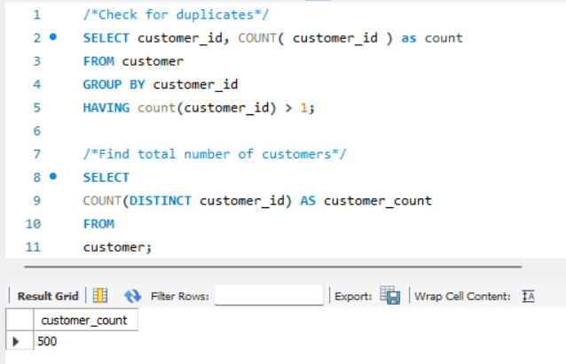

Total Customers, Churned Customers, Churn Rate,

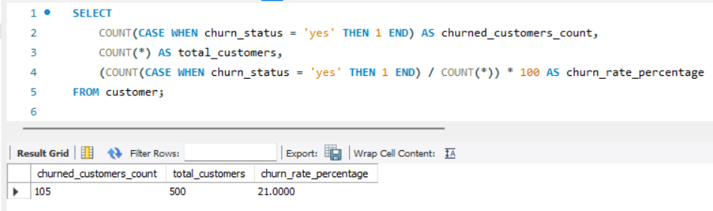

Total Revenue,

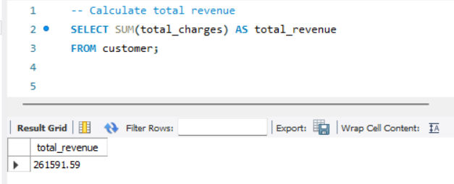

The total revenue lost due to churned customers,

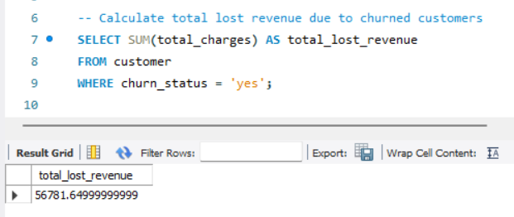

Revenue percentage lost due to churned customers,

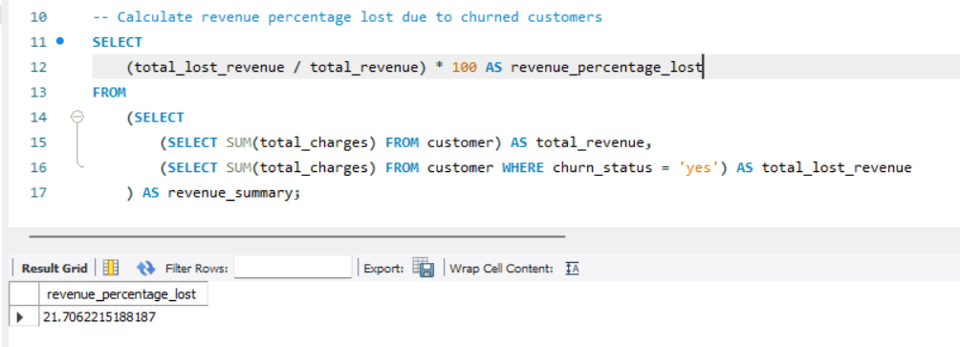

The revenue lost percentage due to churned customer is **21.7%**

The average age of churned customers,

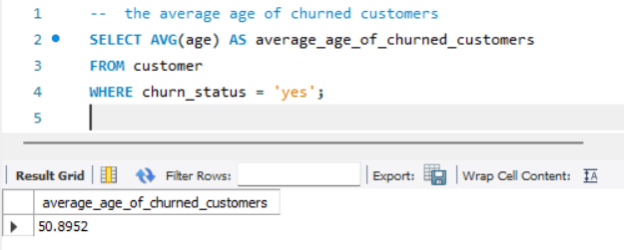

The average age of churned customers is **50**.

The most common contract types among churned customers,

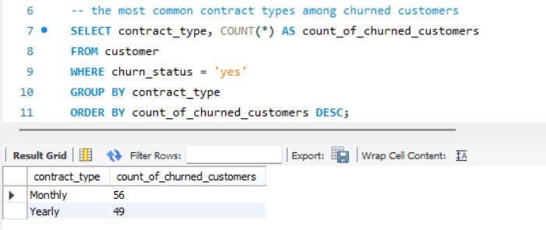

There are **56** churned customers from monthly contract type and **49** churned customers from yearly contract type.

To analyze the distribution of monthly charges among churned customers,

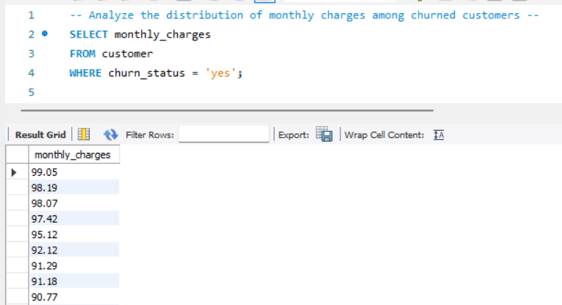

Create a query to identify the contract types that are most prone to churn,

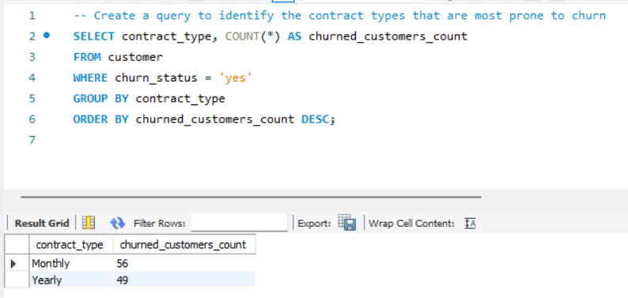

To identify customers with high total charges who have churned,

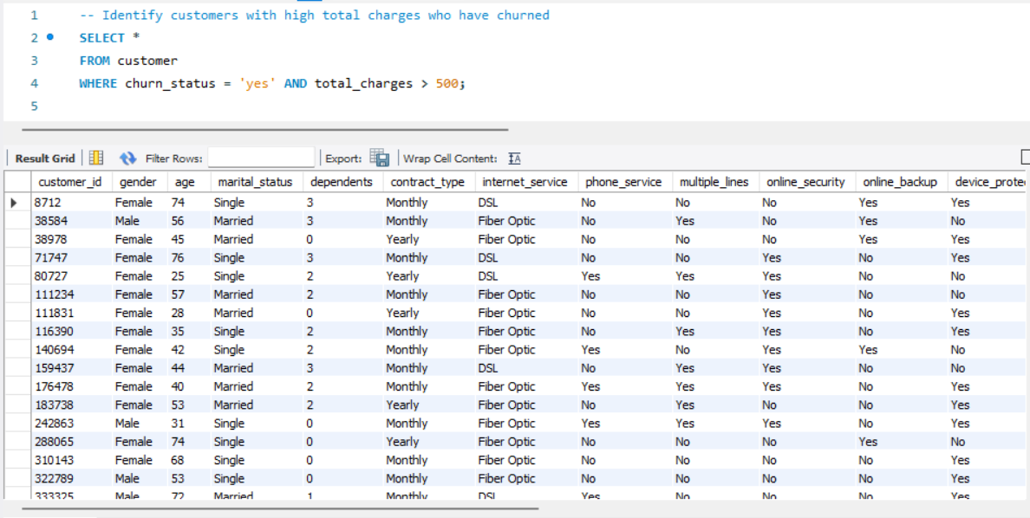

Calculate the total charges distribution for churned customers

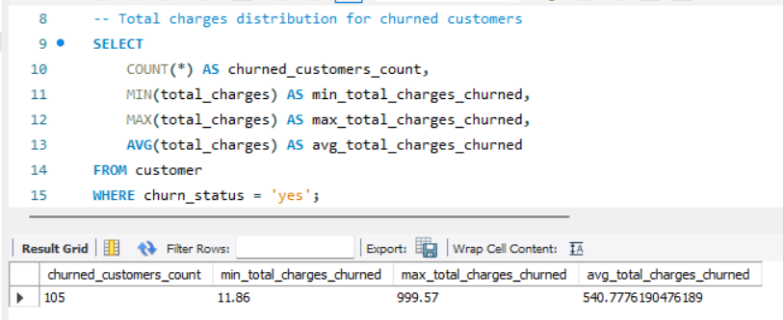

Calculate the total charges distribution for non-churned customers,

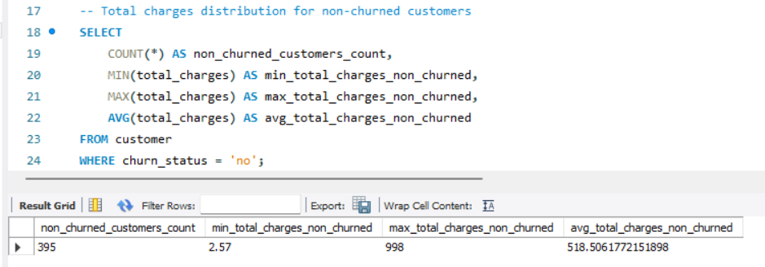

Calculate the average monthly charges for different contract types among churned customers,

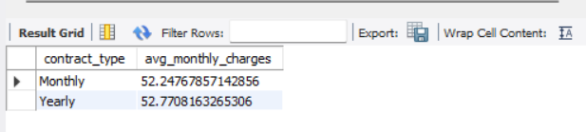

Identify customers who have both online security and online backup services and have not churned,

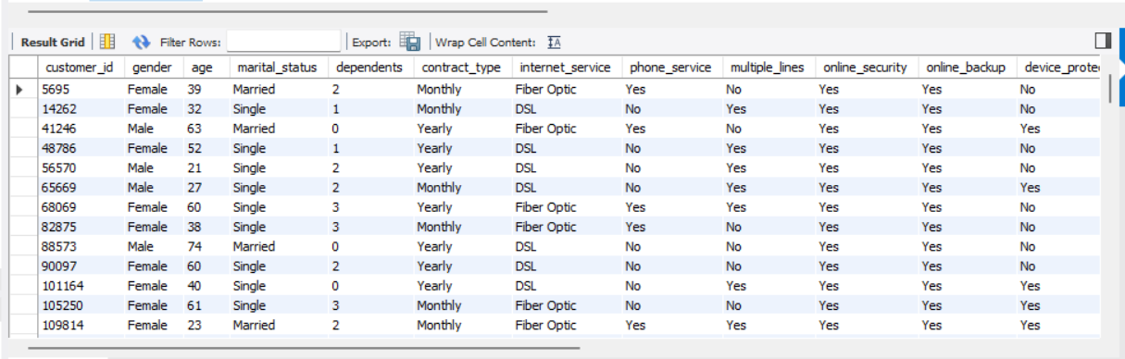

Determine the most common combinations of services among churned customers,

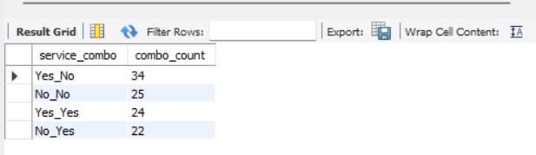

Identify the average total charges for customers grouped by gender and marital status,

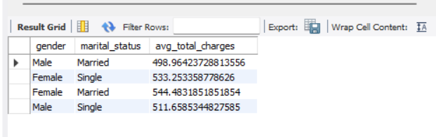

Calculate the average monthly charges for different age groups among churned customers,

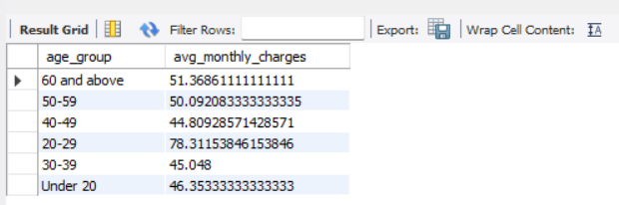

Determine the average age and total charges for customers with multiple lines and online backup,

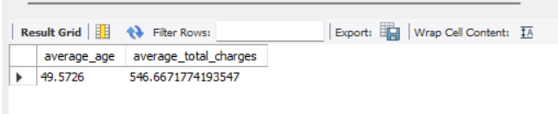

Identify the contract types with the highest churn rate among senior citizens (age 60 and over),

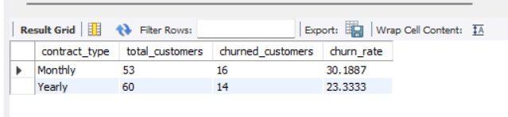

Calculate the average monthly charges for customers who have multiple lines and streaming TV,

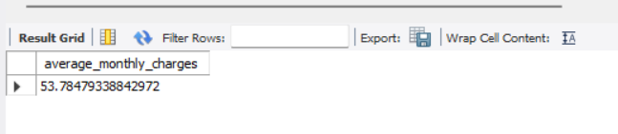

Identify the customers who have churned and used the most online services,

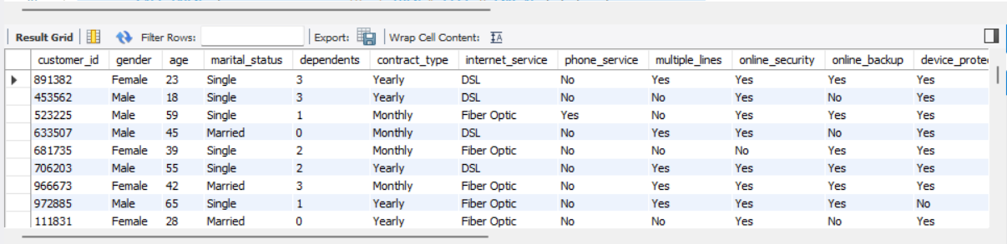

At the end of this report, I attached an SQL file with additional queries for further analysis.

**The key churn indicators are**,

* **Contract Type**: 53% of churned customers were on the month-to-month contract
* **Tech Support**: 52% of churners did not have premium tech support
* **Internet Services:** 56% of churners used Fiber Optic internet service.

**Building the ideal churn customer profile,**

It is a simple churn profile using the key churn indicators I discussed in previous sections, and the churn demographic results below:

* **33%** of churned customers are **above** **60** years old
* **57%** of churned customers are **Female**
* **51%** of churned customers are **Single**
* **71%** of churned customers have **Dependents** and 29% of churned customers have **No dependents** in their household.

**Insights**

The telecom company has **105** churned customers and **21%** churned customer of the total customers.

The top 3 reasons for churn are competitors made better offers, competitors had better devices and attitude of support staff. The telecom company lost ~**$56781.6499,** making it the most expensive type of churn. The key indicators of churn are Monthly Contract, No Tech Support, Fiber Optic internet. And **56%** of churned customers used Fiber Optic Service and **44%** of churned customers used DSL Service.

**Customer Retention Strategies**

* **Loyalty Programs:** Since the top reason for churn is **competitors making better offers,** the company should implement different loyalty programs to retain their customers. For instance, they could reward customers on long-term contracts with discounted rates, free upgrades, or additional features.
* **Improve Customer Support:** Invest in training and development of support staff to ensure they provide excellent customer service. This could include regular coaching and feedback sessions and incentives for staff who receive positive customer feedback.
* **Make better devices:** Evaluate the features, performance, and pricing of your devices to ensure they are in line with market standards and demand.
* **Tech Support:** Since customers who did not have access to tech support were more likely to churn, the company should consider offering this service to all customers.
* **Improve Internet Service:** Invest in improving both your internet services offerings, like faster speeds, more stable connections, and better customer support for Fiber Optic and DSL service customers.
* **Engage High-Value Customers:** Prioritise engaging these customers to prevent them from leaving. Provide personalised offers, send targeted communications, and provide tech support to ensure these customers remain satisfied with their service.
* **After-Sales Service:** Schedule regular check-ins with customers to ensure they are still satisfied with their service. These check-ins could be in the form of surveys, phone calls, or email communications.

**Final Dashboard (Power BI)**

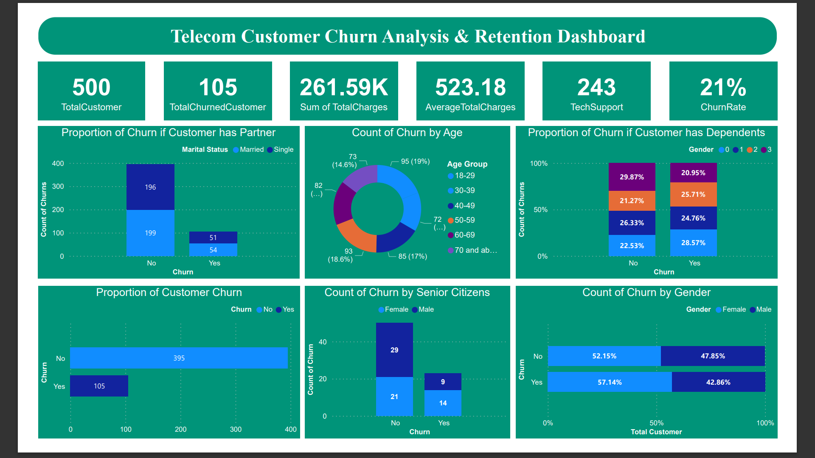

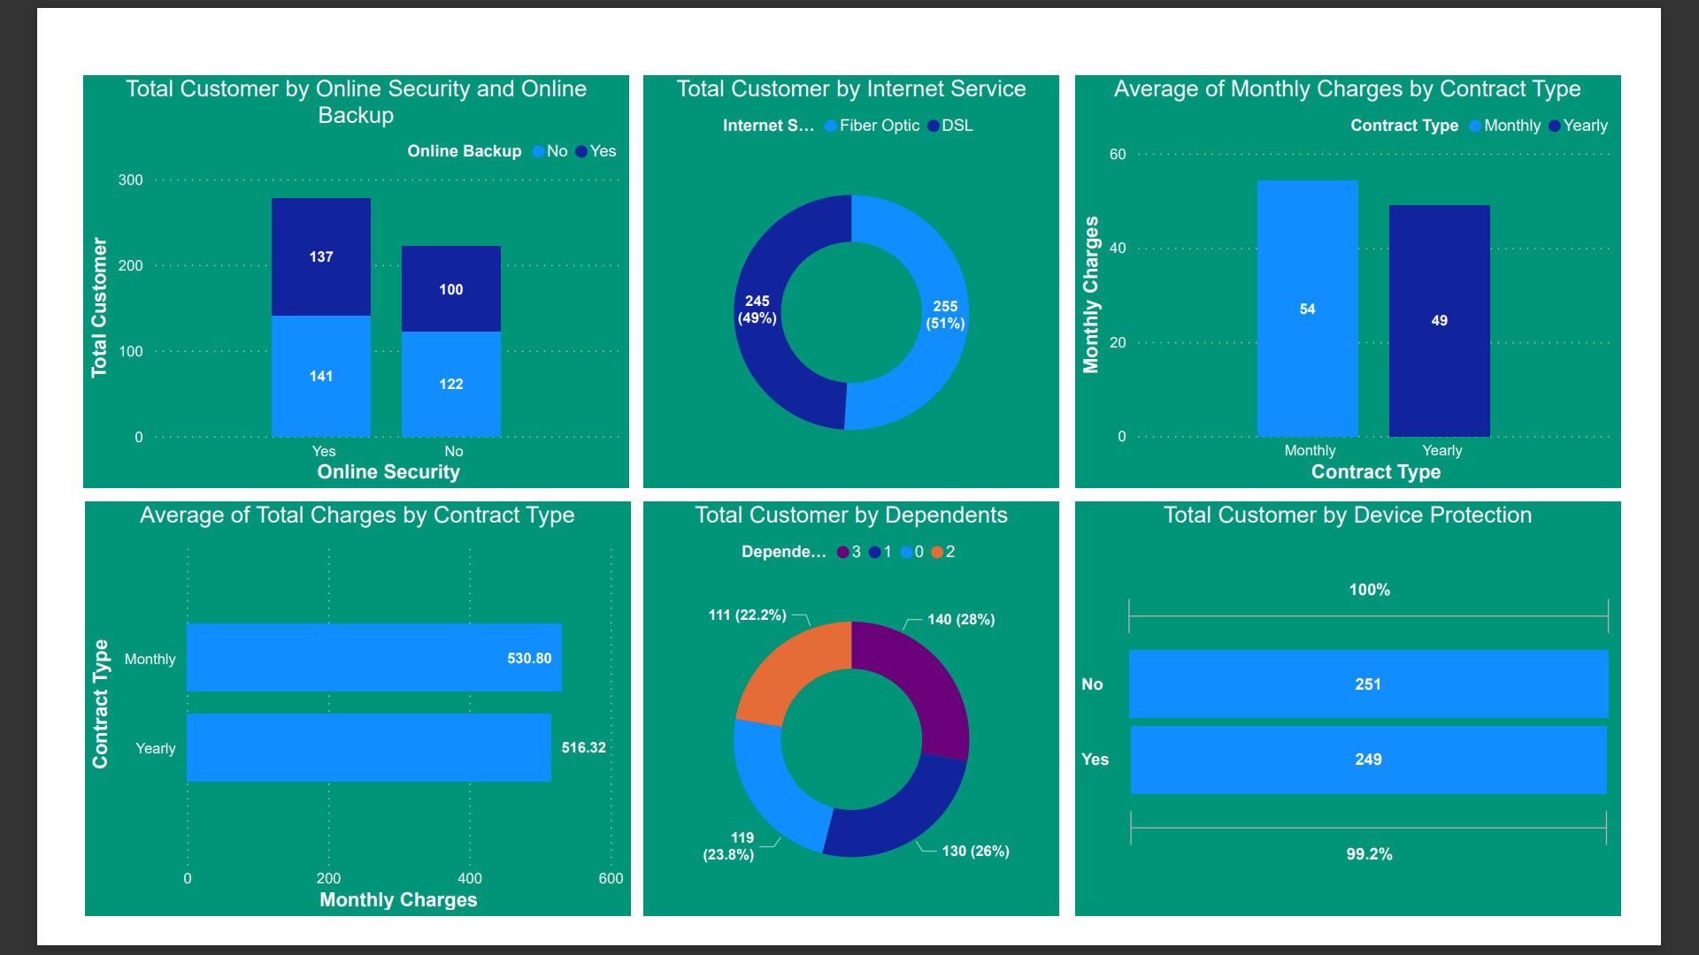

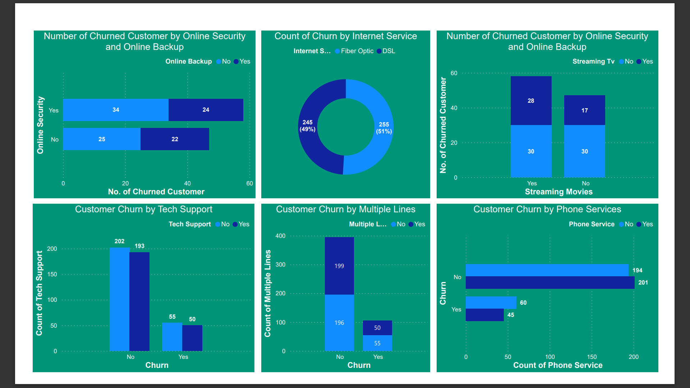

### **Additional Resources and References**

This communicates to the reader that there are additional SQL queries and live Power BI dashboard included for their reference and encourages them to review the attached file for more detailed analysis.

<https://github.com/Beingcharles/Guvi-Final-Capstone---Customer-Churn-Retention-Analysis>

Thanks for Reading!